LAB EX 5

Execute below steps by inserting some data which we can work with. Paste the following into your terminal to create a petshop with some pets in it.

use petshop

C:\Users\Mypc\Desktop\Screenshot_1.png

db.pets.insert({name: "Mikey", species: "Gerbil"})

C:\Users\Mypc\Desktop\Screenshot_3.png

db.pets.insert({name: "Davey Bungooligan", species: "Piranha"})

C:\Users\Mypc\Desktop\Screenshot_4.png

db.pets.insert({name: "Suzy B", species: "Cat"})

C:\Users\Mypc\Desktop\Screenshot_5.png

db.pets.insert({name: "Mikey", species: "Hotdog"})

C:\Users\Mypc\Desktop\Screenshot_6.png

db.pets.insert({name: "Terrence", species: "Sausagedog"})

C:\Users\Mypc\Desktop\Screenshot_7.png

db.pets.insert({name: "Philomena Jones", species: "Cat"})

C:\Users\Mypc\Desktop\Screenshot_8.png

Use find to list all the pets. Find the ID of Mikey the Gerbil.

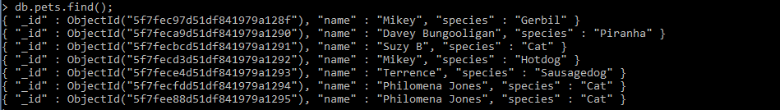

C:\Users\Mypc\Desktop\Screenshot_10.png

Use find to find Mikey by id.

C:\Users\Mypc\Desktop\Screenshot_11.png

Use find to find all the gerbils.

C:\Users\Mypc\Desktop\Screenshot_12.png

Find all the creatures named Mikey.



Find all the creatures named Mikey who are gerbils.

C:\Users\Mypc\Desktop\Screenshot_14.png

Find all the creatures with the string "dog" in their species

C:\Users\Mypc\Desktop\Screenshot_15.png